**Maths Game Challenge 2024**

**Your challenge is to create your own Maths game!**

**It could be a board game or a card game!**

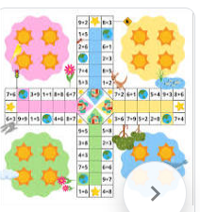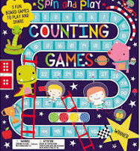**Give your game a Maths theme,**

**it could be about:**

**Fractions, Ordering**

**Decimals, Percentages**

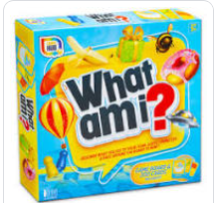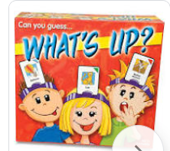**Rounding, Shapes**

**Calculations (+, -, x, ÷)**

**Money, Time, Measures**

**Choose something you have already done in class!**

**It should be a game for 2 or more people and last for at least 5 minutes.**

**You will need to prepare:**

* **All the required equipment**
* **Instructions**

**It must be handed in before the Christmas holiday in a bag, box or container with your name and class clearly labelled.**

**All entries will receive a prize!**

**Best entries will receive a special prize and take part in a games afternoon!**