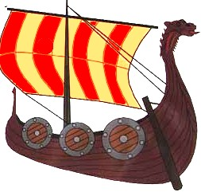
History

Your optional home learning this term is to research the Vikings
You might like to think about:
- Who were they? Where did they come from?
- When did they come to Britain?
- Where else did they travel to?
- What were the Vikings good at?
- How did they influence life in Britain?
- What were their religious beliefs?
- What were the Viking warriors like?
- What were the Viking longships like?
https://www.ducksters.com/history/middle_ages_vikings.php http://www.primaryhomeworkhelp.co.uk/viking/who.html
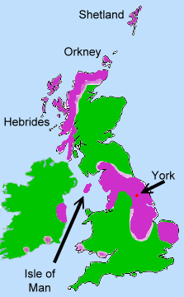
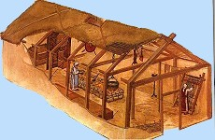
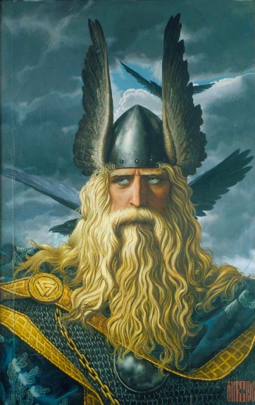
https://www.dkfindout.com/uk/history/vikings/

