Welcome to Year 4 and Team Citron
Your new teacher is Miss Palmer
Your new teaching assistants are Miss Blackwell, Miss Routledge and Mrs Green
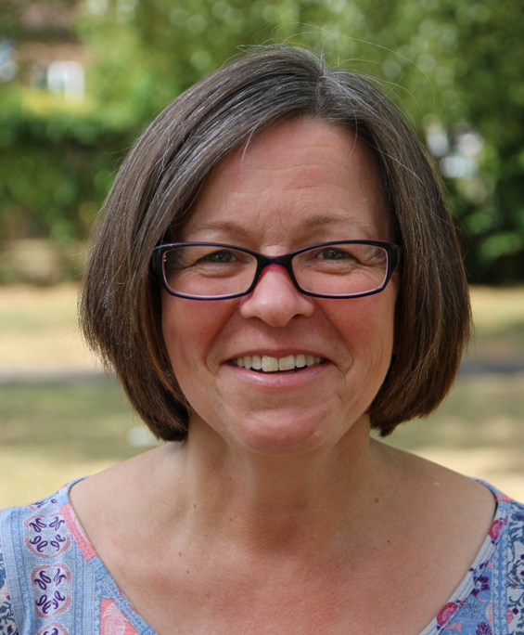
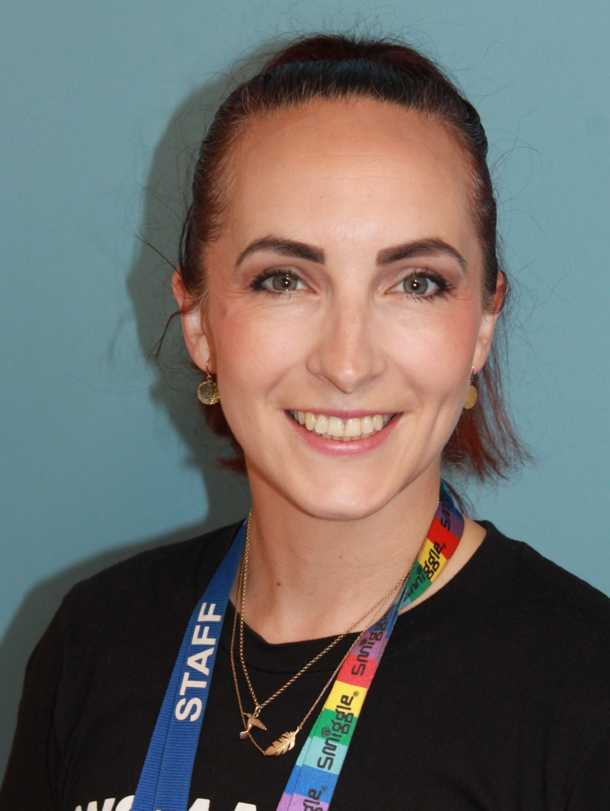
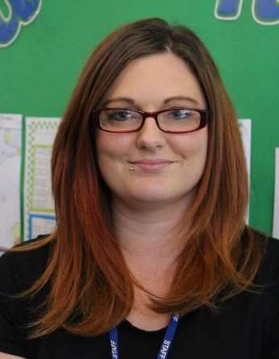
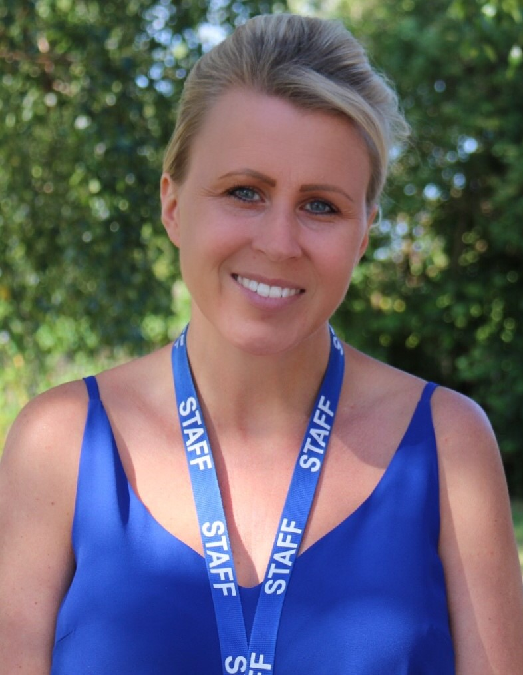

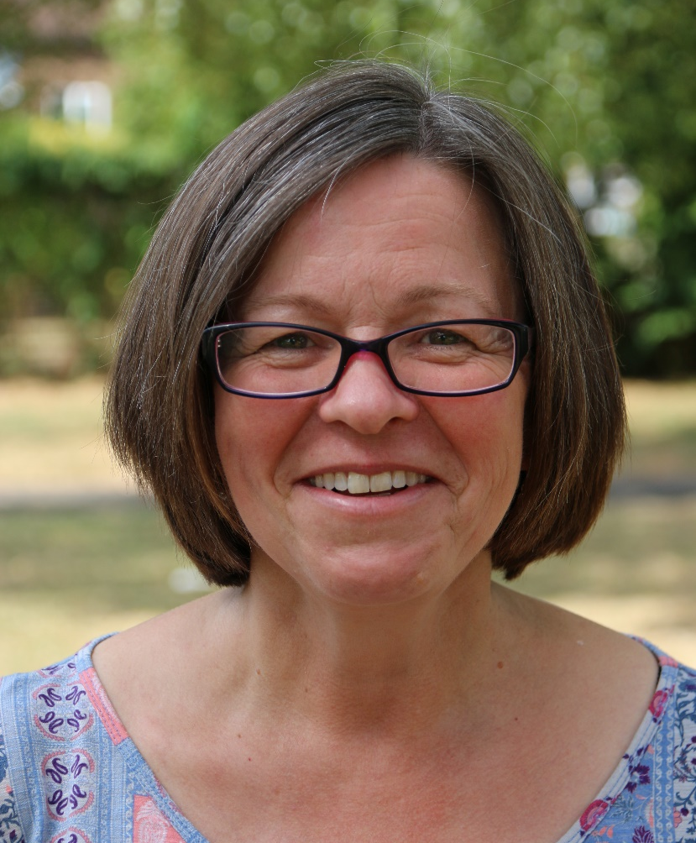
Things you might not know about Miss Palmer, Miss Blackwell, Miss Routledge and Mrs Green:
Miss Palmer has worked at Hobletts Manor for 17 years. She loves being creative and really enjoys teaching art, English and maths. She loves visiting other countries and experiencing new cultures. She also enjoys spending time with her family and discovering new places!
Miss Blackwell loves baking delicious cakes. Miss Routledge enjoys walking her dogs, spending time with her children and swimming. Mrs Green has a keen interest in art, dance, drama, history and English, both in and out of school. She enjoys weekend walks with her family as long as it ends with coffee and cake! Her family motto is ‘Be the best you can be’ and strives for this every day.
In Year 4:
We have lots of exciting new topics to look forward to. In the autumn term, these will include learning about animals and their habitats in science, looking at our local area in geography and history, finding out about Hinduism in RE and learning about the artist, Henri Rousseau in art and recreating his work.

Here’s what our Year 4 children thought about this year…
I enjoyed learning about Henri Rousseau in art. It was fun and I enjoyed using all of the colours. I also enjoyed swimming and doing lots of activities in the water. The last thing I liked was science and doing food chains. It was fun putting the animals in the order that they eat.
Ashnee

I enjoyed learning about the Ancient Egyptians because we made really pretty nightlights and I loved making them!
Gracie
I liked English because of the lovely books we read. I also enjoyed PE, including cricket and American football.
Vinny

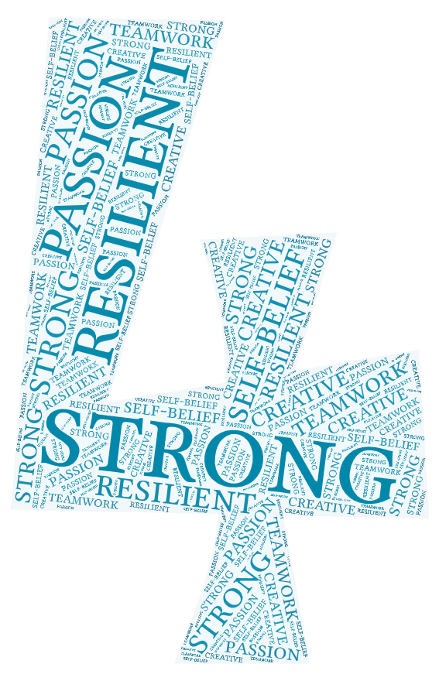
My favourite part of Year 4 was when we did ‘Arthur and the Golden Rope’ in English and got to write our own stories. I also enjoyed the trip to the Hindu Temple and getting to feed the cows! I also liked learning about Henri Rousseau in Art and getting to use different materials like oil pastels.
Zoe

I enjoyed making night lights in DT and also our science topic of Electricity because it was fun and interesting getting to use the electrical equipment.
Buddy
I enjoyed learning lots of fun facts about the Ancient Greeks and the Ancient Egyptians!
Odin

We can’t wait to see you soon!

