Welcome to Year 3 and Team Azure
Your new teacher is Ms Dyer
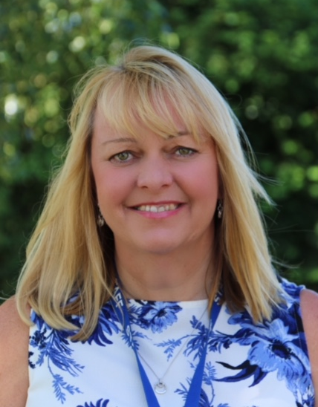
Your new teaching assistant is Ms Allwork and Mrs Elson
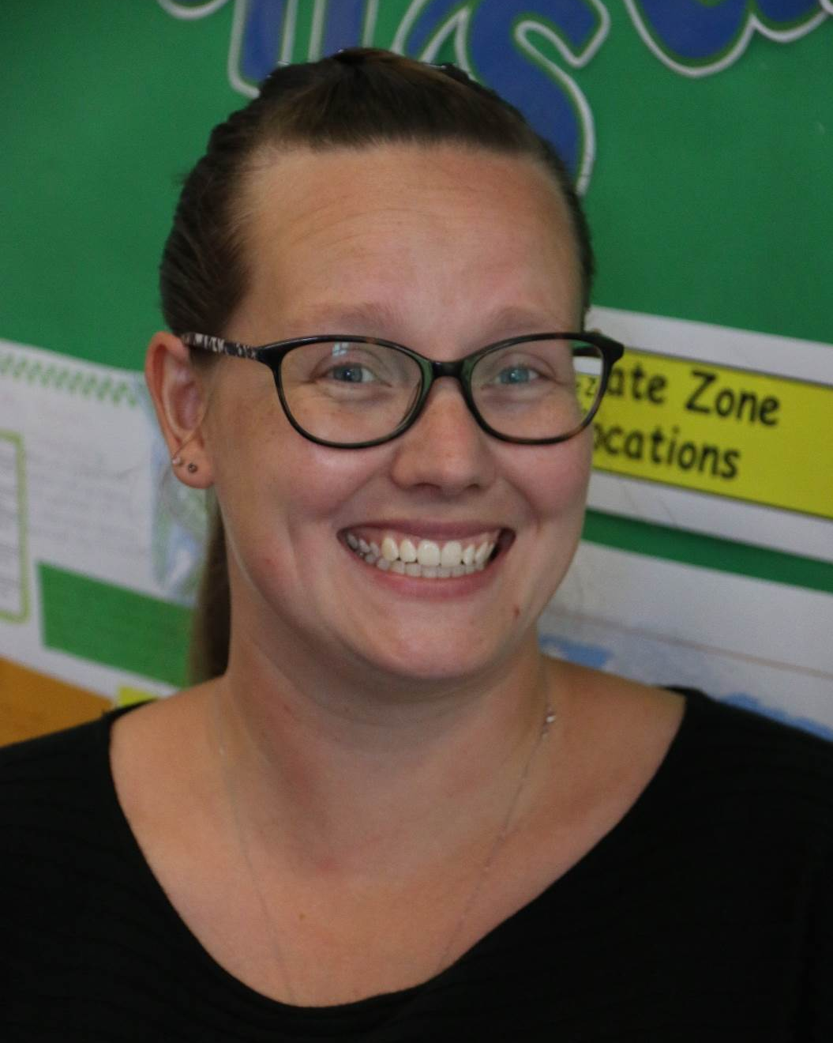
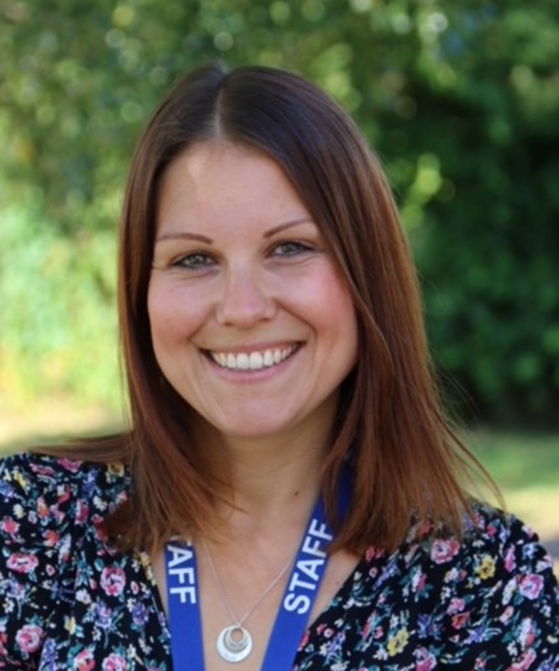
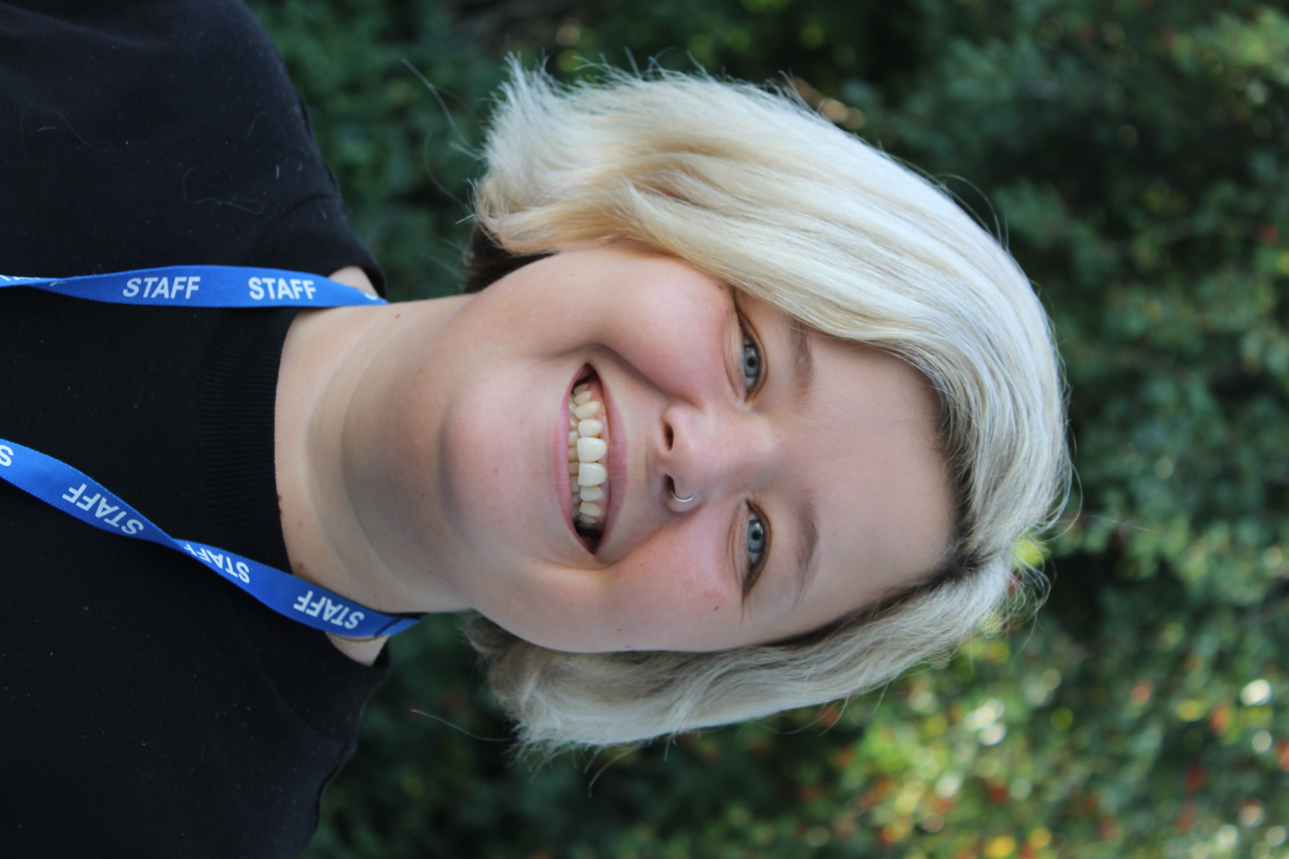

Things you might not know about Ms Dyer, Ms Allwork and Mrs Elson
Miss Dyer loves to take photos of just about everything. She loves to visit different places and enjoys taking long walks with her family and her lovely dog.
Miss Allwork has a real passion for English and Music, and loves to read. She adores going on adventures and making special memories with her family.
Mrs Elson loves to read and spend time with her four children.

In Year 3:
We have lots of exciting new topics to look forward to. In the autumn these will include ‘Through the Ages.’
During this topic, we will be learning all about how people lived and the art they produced.

Here’s what our Y3 children thought about Azure class this year…

I have enjoyed being in year 3 because it was amazing. All of the teachers were really kind and we did really fun things.
I have enjoyed learning about fossils in science and had fun in P.E I have also found it is fun to learn times tables too! I hope you enjoy it too!

I liked being with the teachers because they did nice things with us, like making fossils and purses.

Amelia
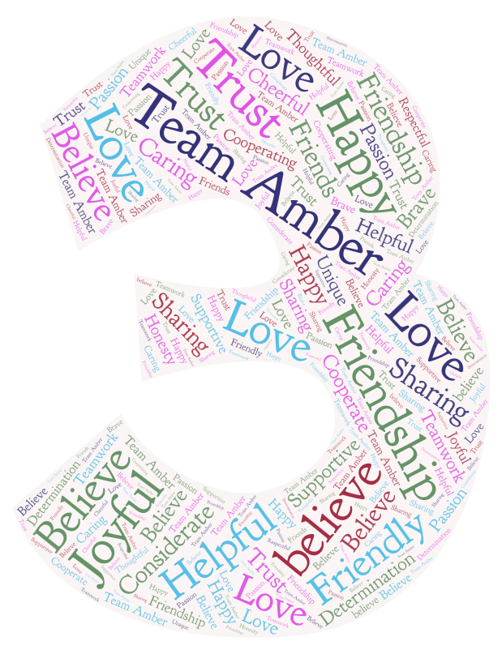
I liked learning about all of the lessons; it was fun and I learnt lots of things. I loved making a Lotus Flower in art out of clay
I have enjoyed learning about The Stone Age this year. I loved RE and History, learning about Boudicca. I have learned lots of new things about them and it was super fun.
Sonny
“We can’t wait to see you soon

