Through the Ages Optional Home Learning Project
Year 3

During Autumn Term, Year 3's topic focus will be the through the ages. To support your child's learning and understanding of the Stone Age, Bronze Age and Iron Age, we would like to invite you and your child to take part in a homework project. Your child can choose one of the following categories which they could do for their project:

- Research an aspect of pre-historic Britain: the Stone Age, Bronze Age or Iron Age and use what you find out to create a fact file.
- Cave homes – During the Stone Age, people lived in caves. If you had to live in a cave, what would you like it to look like and what would be in it? Be as creative and imaginative as you like! Maybe you could build your own 3D cave to bring in!
- Make up your own story, it can be about anything you like and you can tell it through cave art pictures.
- Stone Age recipes – Stone Age people could not pop to the shops for food. Everything they ate had to be caught or collected. Write your own recipe for a Stone Age dinner using the sort of ingredients that would be available to them.
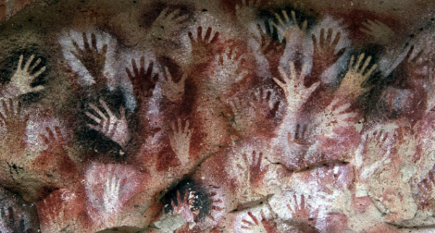
- You could even design your own Stone, Bronze or Iron Age house.
- Prehistoric Tools – Find out and write about tools that were used in each of the Ages (Stone, Bronze and Iron). You can also draw pictures to go with your writing.
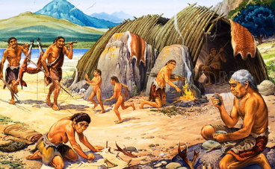
- Stone Age Jewellery – Stone Age people made bead necklaces, pendants and brooches. Make your own piece of jewellery which you can bring in.
- Stonehenge Model – Find out about Stonehenge. Make a model or draw a landscape picture of Stonehenge and write some information to go with it.

These activities can be carried out in a way that suits your child best. For example; you could make a fact book, a plan, a model or a drawing.

Completed projects can be brought into school as soon as they are completed but by the latest Wednesday 17th December.

Web links that you may find helpful
www.bbc.co.uk/history/ancient/british_prehistory
https://www.bbc.co.uk/bitesize/topics/z82hsbk/year/zmyxxyc
https://kids.britannica.com/kids/article/Stone-Age/353814
https://kids.britannica.com/kids/article/Bronze-Age/352883
https://kids.britannica.com/kids/article/Iron-Age/353302

