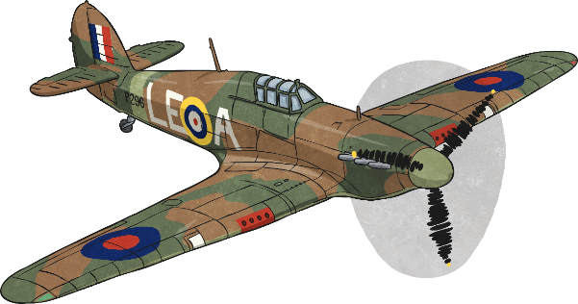
History
Your homework this term is to research World War II.

You might like to think about:
- Why WWII started
- When the war started and finished
- Which countries were involved
- Important events which happened during the war
- Who the main leaders were
- How people protected themselves
- How it affected the British people
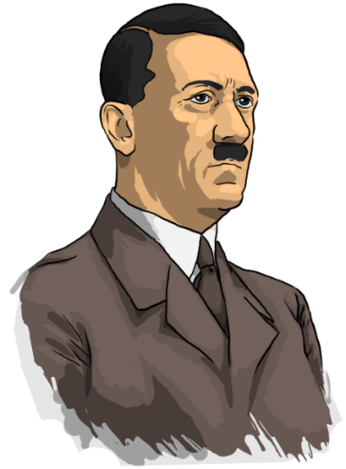
You can present your research in any way you choose, for example a power point presentation, a poster, a report, maybe even a model of a shelter etc.

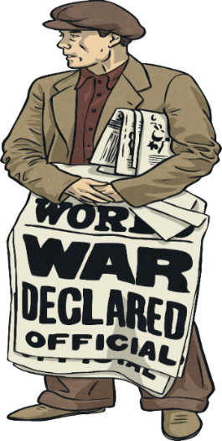
Enjoy and we look forward to receiving your completed homework before the Christmas Holidays!

